Family Safety Tips
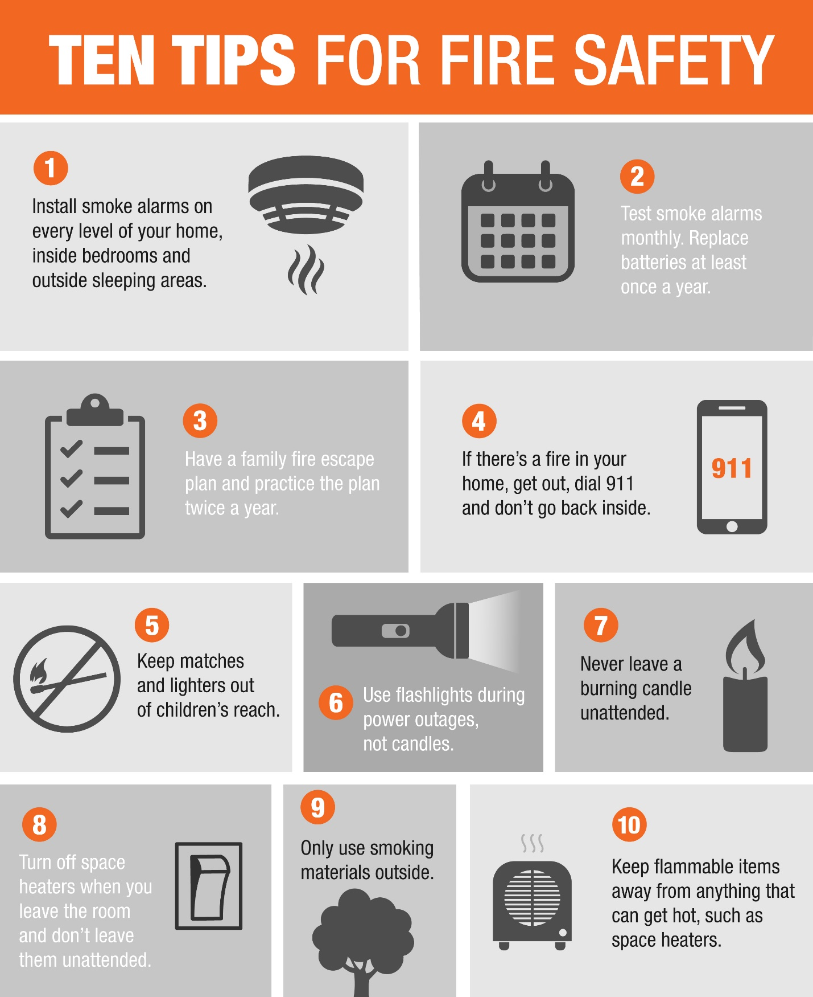

American homes suffer an unwanted fire every 10 seconds, and every 60 seconds they suffer a fire serious enough to call the Fire Department. Most importantly, every two and half hours, someone is killed in a house fire.

​

Protecting your family from fires requires advance planning for what to if there is a fire. This includes the use of protective devices, such as smoke detectors to provide early warning of fire, especially at night.

How Fires Kill
Most victims of fire succumb to the smoke and toxic gases and not to burns. Fire produces poisonous gases that can spread rapidly from the fire itself to claim sleeping victims unaware of the fire.

Common Causes of Fires
Most house fires occur in the kitchen while cooking and are the leading cause of injuries from fire. Common causes of fires at night are carelessly discarded cigarettes, sparks from fireplaces and heating appliances left too close to furniture or other combustibles.

​

Playing - Children playing with matches or lighters is a leading cause of house fires and one in which the children and others present are often hurt. Children have a natural curiosity about fire and are tempted to play with matches or lighters. Even though children are curious about fire, they may

become frightened and confused in a fire and hide rather than escape to safety. Children are often found hiding in closets or under beds where they feel safe. It is crucial to discuss with your children the dangers of fire.

Clothing - Clothing fires are a significant cause of fire injuries to children (and to adults too). They set their clothes on fire by getting to close to heat sources such as open fires or stoves, or when playing with matches or lighters. Here too, the best defense is a respect for fire and training in what to do if their clothes do catch fire. Their natural reaction is to run - which will make the situation worse. Stop, drop, and roll is taught as the correct action and has saved many lives in clothing fires. The moment clothes start to burn, stop where you are, drop to the ground, cover your face with your hands and roll repeatedly to smother the flames.

Older Adults - The risk of death from fire for Americans age 65 and over is two times greater than the risk for adults under 65, and hospital stays of more than 40 days are common for older burn victims. Thus, older people need to be especially careful with fire. People can become victims of fire by falling asleep smoking, either in bed or in a favorite chair, especially after consuming alcohol or taking medication. Ashtrays emptied before smoldering materials are completely out also start a number of fires in homes of smokers. Cooking is a major cause of fire injuries among older persons when loose fitting clothing is ignited as the wearer reaches over a hot burner, or slips and falls onto the stove.

