Occupant Load Determination

for Bars & Restaurants

**Occupant load purposes**

Occupant load factors have been established through studies showing how much space people take

for activities and movement. These occupant load factors are based

on how the space is being used.

The state fire and building codes use occupant load calculations to establish:

•

Egress provisions (such as the number of doors needed and the width of doors, stairs, aisles,

and

corridors).

•

When fire protection systems are r

equired (sprinklers, fire alarm systems,

etc.).

•

The type of occupancy (in some

cases).

**Determining the occupant load in assembly spaces**

Determining the occupant load in assembly spaces is typically a little more complicated than in most

other uses. The fi

rst step is to determine the type of seating: fixed or not fixed.

**Fixed seating**

Fixed seating is typically bleachers, benches, pews, or seats that are fixed in place and cannot be

moved. Here are the common measurements for fixed searing:

•

Bleachers and

pews: one person for each 18 inches of

length.

•

Booths (as in a restaurant): one person for each 24 inches of

length.

•

Seats (typically with arm rests): one person per

seat.

**Areas without fixed seating**

Here are the common occupant load factors used in assem

bly settings (such as restaurants, bars,

places of worship, libraries, museums, etc.) that do not have fixed seating. These values come from

Table 1004.5 of the 2020 Minnesota State Fire Code (MSFC):

•

Table and chair seating: 15 sq. ft. per person (net

area

).

•

Chair seating (no tables): 7 sq. ft. per person (net

area).

•

Standing areas and dance floors

–

7

sq. ft. per person (net

area).

•

Waiting, queuing areas

–

5

sq. ft. per person (net

area).

•

Exercise areas

–

50

sq. ft. per person (gross

area).

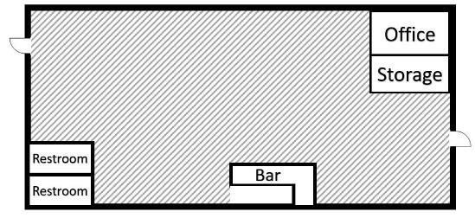

**Gross vs. net areas**

The fire and building codes measure these areas slightly

differently. For most occupancies, gross floor area is used. Gross

floor area is the space bounded by the walls and includes all

spaces except for shafts or courts. In Figure 1,

the shaded areas

represent the gross floor area. The “X” represents a shaft

or court that does not get included in the

measurement.

*Figure 1. Gross floor*

*area*

*Figure 2. Net floor*

*area*

Net floor ar

ea is used where there are typically larger numbers

of people. Net area is the space that can actually be occupied

by people and excludes areas where people would not

normally congregate (such as stairs, hallways, restrooms,

mechanical rooms, etc.). In Fig

ure 2, the shaded areas

represent the net floor area. The white colored areas are not

included in the measurements.

**Applying occupant load factors to buildings**

To determine the occupant load of a space, divide the size of the space

by the occupant load

factor(s) of Table 1004.5 of the 2020 MSFC (see common ones above). In many assembly settings,

there will be more than one use. Please see the following example.

**Example of occupant load determination**

The following is an example of

an assembly venue with multiple uses. The occupant load is

determined by measuring the areas, dividing by the occupant load factors for each area, and adding

the numbers together.

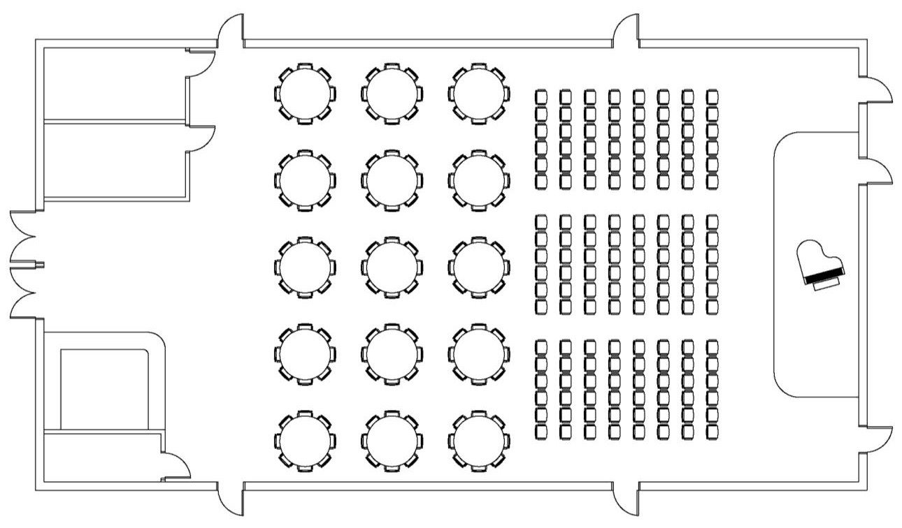

Restroom



Restroom



Stage

’ x 40’

15



Cashier



Office



Chairs 30’ x

’

70



Table and chairs 30’ x 70’



Waiting area

15

’ x 20’

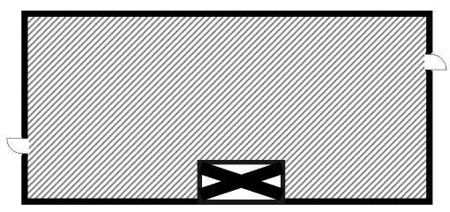

Because there are multiple uses here (chair seating, table and chair seating, waiting area, and a

stage), there are multiple calculations:

•

Chair seating (shown in

Yellow):

o

30

ft. by 70 ft. = 2,100 sq.

ft.

o

= 300

2

,100 sq. ft. divided by 7 sq. ft. per person

Persons.

•

Table and chair seating (shown in

blue):

o

30

ft. by 70 ft. = 2,100 sq.

ft.

o

2

,100 sq. ft. divided by 15 sq. ft. per person

= 140

Persons.

•

Waiting / queuing area (sh

own in

green):

o

ft. by 20 ft. = 300 sq.

15

ft.

o

300

sq. ft. divided by 5 sq. ft. per person =

60

persons.

•

Stage area (shown in

orange)

o

15

ft. by 40 ft. = 600 sq.

ft.

o

600

sq. ft. divided by 15 sq. ft. per person =

40

persons.

•

Total occupant load = 540 persons

=

(

chair = 300, tables = 140, waiting = 60, stage

40).

**Note:**

If the occupant load calculations are to ensure compliance with the governor’s executive order

related to COVID

-

19

(

75

percent occupancy

and not to exceed

25

0

people

—

effective

Mar. 15

,

2021

)

,

multiply

the total occupant load determined above by

.75

and round up. This is for patrons and

customers; staff are not included in these limits.

[.](https://staysafe.mn.gov/)

Developed June 5,

2020

–

Updated

Mar

ch

15

, 2021