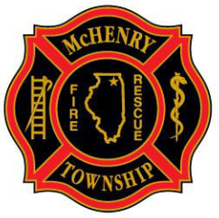
Authority Having Jurisdiction (AHJ)
Authority Having Jurisdiction (AHJ): An organization, office, or individual responsible for enforcing the requirements of a code or standard, or for approving equipment, materials, an installation, or a procedure.
The McHenry Township Fire Protection District is not the AHJ, but rather works with and supports in part or whole 9 different City’s, Villages and Counties. The MTFPD works with each individual entity building department to ensure all ordinances, codes and requirements are met for compliance.

- City of McHenry
- McHenry County
- Village of Johnsburg
- Village of Bull Valley
- Village of Lakemoor
- Village of Ringwood
- Village of Island Lake
- Village of Holliday Hills
- Village of McCullom Lake

